

|  |  |  |  |  |  |  |  |  |
| --- | --- | --- | --- | --- | --- | --- | --- | --- |
|  | | | | | | | | |
|  | | ABC Call Volume Trend Analysis | | | | |  | |
|  |  | | | | | | |  |
|  | | | |  |  | | | |
|  | | | | Ramesh Abbigeri |  | | | |
|  | | | |  |  | | | |
|  | | |  | | |  | | |

#### Project Description:

Customer support is one of the important sectors of Business for its growth. Customer support means, a company answers to customer’s question and solves customer’s problem in order to built trust of their customers and attract more customers.

Company can give customer support in any ways or in many ways. Different types of customer support involve

* Through Call
* Through mail
* In person Customer support
* Through customer support center

Company can choose any of the type for customer support or all type of customer support to build customer trust and attract more customers.

Let’s look at some of the most impactful AI-empowered customer experience tools you can use today:

Interactive Voice Response (IVR), Robotic Process Automation (RPA), Predictive Analytics, Intelligent Routing

In a Customer Experience team there is a huge employment opportunity for Customer service representatives A.k.a. call center agents, customer service agents. Some of the roles for them include: Email support, Inbound support, Outbound support, social media support.

Inbound customer support is defined as the call center which is responsible for handling inbound calls of customers. Inbound calls are the incoming voice calls of the existing customers or prospective customers for your business which are attended by customer care representatives. Inbound customer service is the methodology of attracting, engaging, and delighting your customers to turn them into your business' loyal advocates. By solving your customers' problems and helping them achieve success using your product or service, you can delight your customers and turn them into a growth engine for your business.

This project is also based on customer support analysis. Solutions are found for questions asked and insights are drawn from those answers.

#### Approach:

Dataset of a Customer Experience (CX) Inbound calling team for 23 days is provided. Data includes Agent_Name, Agent_ID, Queue_Time [duration for which customer have to wait before they get connected to an agent], Time [time at which call was made by customer in a day], Time_Bucket [for easiness we have also provided you with the time bucket], Duration [duration for which a customer and executives are on call, Call_Seconds [for simplicity we have also converted those time into seconds], call status (Abandon, answered, transferred).

For any of data analytics projects to be completed understanding the dataset is the important and mandatory step of data analytics. Keeping this in mind I went through the dataset provided and understood columns present in it, then checked for null values, then found insights for the questions asked. These questions are listed below.

1. Calculate the average call time duration for all incoming calls received by agents (in each Time_Bucket).
2. Show the total volume/ number of calls coming in via charts/ graphs [Number of calls v/s Time]. You can select time in a bucket form (i.e., 1-2, 2-3, ….)
3. As you can see current abandon rate is approximately 30%. Propose a manpower plan required during each time bucket [between 9am to 9pm] to reduce the abandon rate to 10%. (i.e., You have to calculate minimum number of agents required in each time bucket so that at least 90 calls should be answered out of 100.)
4. Let’s say customers also call this ABC insurance company in night but didn’t get answer as there are no agents to answer, this creates a bad customer experience for this Insurance company. Suppose every 100 calls that customer made during 9 Am to 9 Pm, customer also made 30 calls in night between interval [9 Pm to 9 Am] and distribution of those 30 calls are as follows:



Now propose a manpower plan required during each time bucket in a day. Maximum Abandon rate assumption would be same 10%.

Assumption: An agent work for 6 days a week; On an average total unplanned leaves per agent is 4 days a month; An agent total working hrs is 9 Hrs out of which 1.5 Hrs goes into lunch and snacks in the office. On average an agent occupied for 60% of his total actual working Hrs (i.e., 60% of 7.5 Hrs) on call with customers/ users. Total days in a month is 30 days.

#### Tech-Stack Used:

Microsoft Excel 2019 is used to perform analysis. Analysis is carried out by creating the pivot table in Microsoft Excel and then graphs/charts were drawn by referring to pivot table.

#### Insights:

Customer support is one of the tough processes of business. Customer support seems tough because it needs more man power and more patience for workers to handle different problems and questions of customers. If a worker fails to solve the questions of customer, then it will impact company, and reduce customer trust on company.

insights were drawn based on the problem statement given with dataset.

1. Calculate the average call time duration for all incoming calls received by agents (in each Time_Bucket).

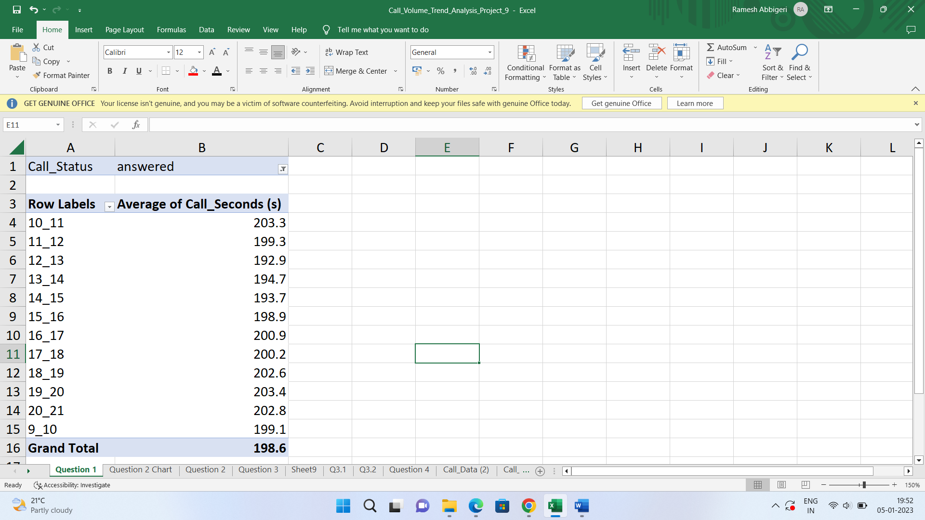

Average call time duration for all incoming calls received by agents is 198.6 sec.

1. Show the total volume/ number of calls coming in via charts/ graphs [Number of calls v/s Time]. You can select time in a bucket form (i.e., 1-2, 2-3, ….)

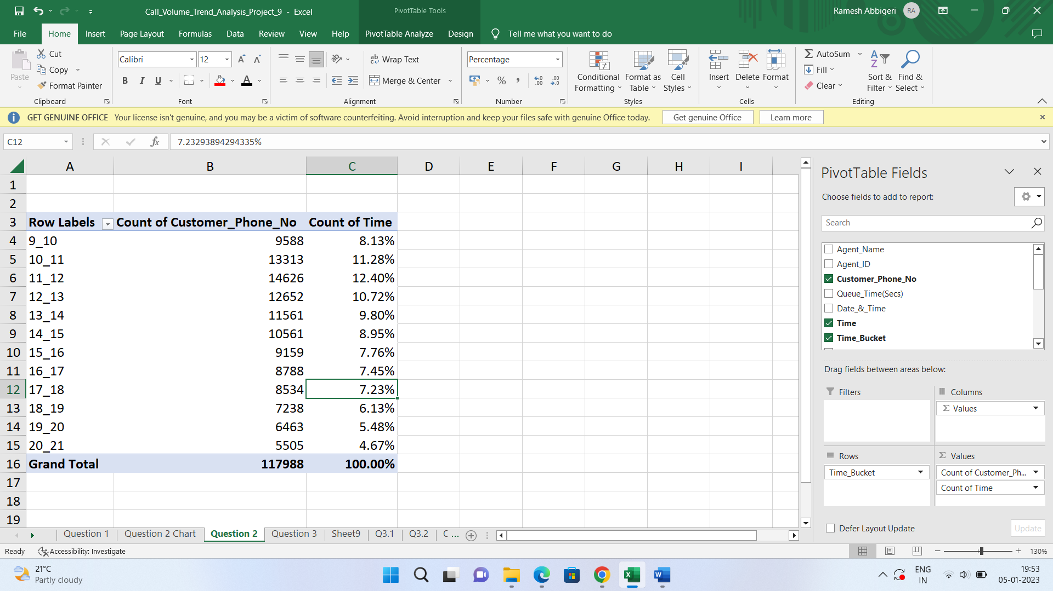

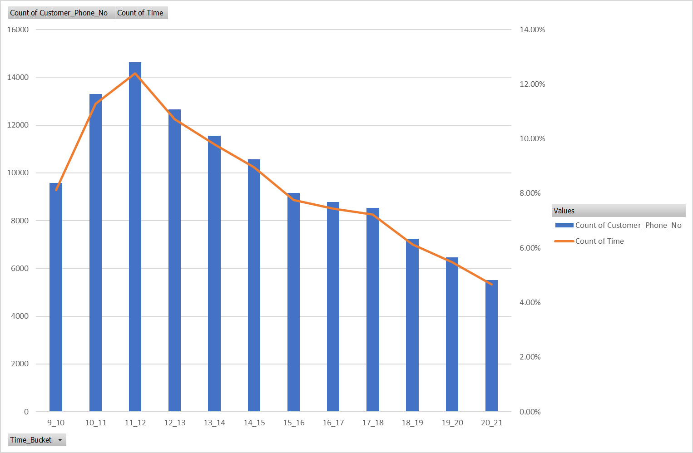

Above combo graph shows relation between Time_bucket vs number of calls and percentage of calls.

We can observe that more number of calls were answered in interval 11-12.

1. As you can see current abandon rate is approximately 30%. Propose a manpower plan required during each time bucket [between 9am to 9pm] to reduce the abandon rate to 10%. (i.e., You have to calculate minimum number of agents required in each time bucket so that at least 90 calls should be answered out of 100.)



|  |  |
| --- | --- |
| Agent working hour | 9 |
| Agent on flour work hour | 7.5 |
| Agent actual working hour | 4.5 |
| Days spent agent work in week | 5 |

|  |  |
| --- | --- |
| Number of days in month | 30 |
| Number of days agent works in month without leave | 26 |
| Number of days agent actual works | 22 |

Total call duration to answer the total number of calls (in sec) = 1018818

Total call duration to answer the 90% of calls (in hrs) = 255

Working hour of a person = 4.5

Average number of manpower required for 10% abandon rate for per day = 57



Red colored cells show the Time_Bucket where it needs more man power than average number of man power per day whereas yellow-colored cells show the Time_Bucket where it needs less man power than the average number of man power.

To manage this problem company can hire the workers on the bases of time shift. Doing this company can answer most of calls and also save its capital.

1. Let’s say customers also call this ABC insurance company in night but didn’t get answer as there are no agents to answer, this creates a bad customer experience for this Insurance company. Suppose every 100 calls that customer made during 9 Am to 9 Pm, customer also made 30 calls in night between interval [9 Pm to 9 Am] and distribution of those 30 calls are as follows:



Now propose a manpower plan required during each time bucket in a day. Maximum Abandon rate assumption would be same 10%.

Call volume daily(9am-9pm) = 5130

If we provide support in night(9pm-9am) = 1539

Addition hours required 44support in night(9pm-9am) = 1539

Addition hours required = 76.41

Addition head count required for per day in night(9pm-9am) = 17

Total head count = 74



Red colored cells show the Time_Bucket where it needs more man power than average number of man power per day whereas yellow-colored cells show the Time_Bucket where it needs less man power than the average number of man power.

To manage this problem company can hire the workers on the bases of time shift. Doing this company can answer most of calls and also save its capital.

#### Result:

* For customer support we come to know that it is better to hire workers based on time shift.
* We should hire more workers as company grows and engage with more customers. So, that more calls can be answered.
* More calls from customers can be expected in day time rather than night time.
* Solving this kind of real-world problems helped me to upgrade my skills and gave confidence to become data analyst.

#### Appendix:

Excel file:

<https://docs.google.com/spreadsheets/d/1ALd3xQeSsfcGbVu674Xjj0C1Nv31huQk/edit?usp=sharing&ouid=111799299037130426024&rtpof=true&sd=true>